Bizspace, The Cobalt Building
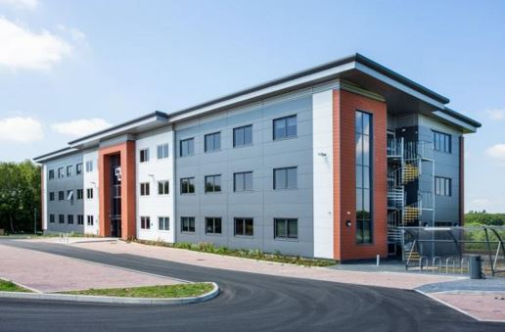
1600 Eureka Park, Ashford TN25 4BF

ASHFORD’S NEWEST PURPOSE-BUILT FLEXIBLE OFFICE WORKSPACE
16,584 SQ.FT. OVER 3 FLOORS
TO LET
- On-site Car Parking | - Meeting Room Facilities
- Various sizes - 172sq.ft. to 424 sq.ft. | - 24 Hour Access
- Multi-suite lets available

Rents from: £700 per calendar month exclusive

LOCATION
The Cobalt Building is located at Lower Pemberton on the 96 acre Eureka Business Park. This is a modern, well-established prime business location, located just 2.5 miles north-west of Ashford town centre and 1 mile north-west of junction 9 of the M20 motorway.

Ashford, one of Kent’s designated growth centres, currently has a population of approximately 75,000 inhabitants and is set to grow substantially in the next 20 years. The town is centrally located within the county, benefitting from a fine communications network via the A20/M20 and five mainline railways. Ashford International Passenger station gives direct access to northern continental Europe via Eurostar and London is some 38 minutes distant via HS-1.

DESCRIPTION
This is a brand new, purpose-built flexible workspace hub with multiple suites available from 172 sq.ft. to 424 sq.ft. Each unfurnished suite is fully carpeted and centrally heated and benefits from superfast ethernet broadband cabling. All offices have fully opening windows giving plenty of natural light and allowing good air flow. There are fully equipped kitchen and WC facilities on each floor, and shower facilities and cycle racks are available to all occupiers. A dedicated, locked mailbox is also provided for each suite.
There is an attractively furnished and welcoming lobby area, and two large furnished meeting rooms are available by arrangement for ad hoc or regular use.
There is ample free parking and access is available 24 hours/365 days by way of a secure keyfob entry system. CCTV is also provided for security.

ACCOMMODATION
Suite sizes range from 172 sq.ft. (suitable for up to 3 people) to 424 sq.ft (up to 10 people) with a variety of options in between. Please see attached list of available suites. If larger space is needed it is possible to take multiple suites, subject to availability.

SERVICES
All main services are connected to the premises. Superfast ethernet broadband cabling is available to every office.

BUSINESS RATES
The premises will need to be re-assessed upon completion and first occupation. Occupers are responsible for their own Business Rates, although many may qualify for Small Business Rate Relief.
The uniform business rate multiplier for the year 2022/23 is 49.9p.

TERMS
The suites are available on 12 month licence agreements with rents starting from just £700 per calendar month. All rents are inclusive of legal fees, buildings insurance and maintenance, broadband connection, car parking, window cleaning and daily cleaning of public areas. A 2-month rent deposit is payable upon first occupation, and 3-months notice is required to terminate the agreement.

ENERGY PERFORMANCE CERTIFICATE
The premises have been assessed as 22 (Band A). Both certificate and report can be viewed at https://find-energy-certificate.digital.communities.gov.uk/

VIEWING
Strictly by appointment through Stafford Perkins. Tel: 01233 613900.

ANTI MONEY LAUNDERING REGULATIONS
In order to comply with Anti-Money Laundering Regulations, we are required to obtain proof of identity for prospective tenants.
CODE OF PRACTICE
Applicants should be aware that the Code of Practice for Commercial Leases in England and Wales strongly recommends you seek professional advice from a qualified Surveyor, Solicitor or Licensed Conveyancer before agreeing or signing a Business Tenancy Agreement. The Code is available through professional institutions and trade associations

